DATE: 11.08.2019
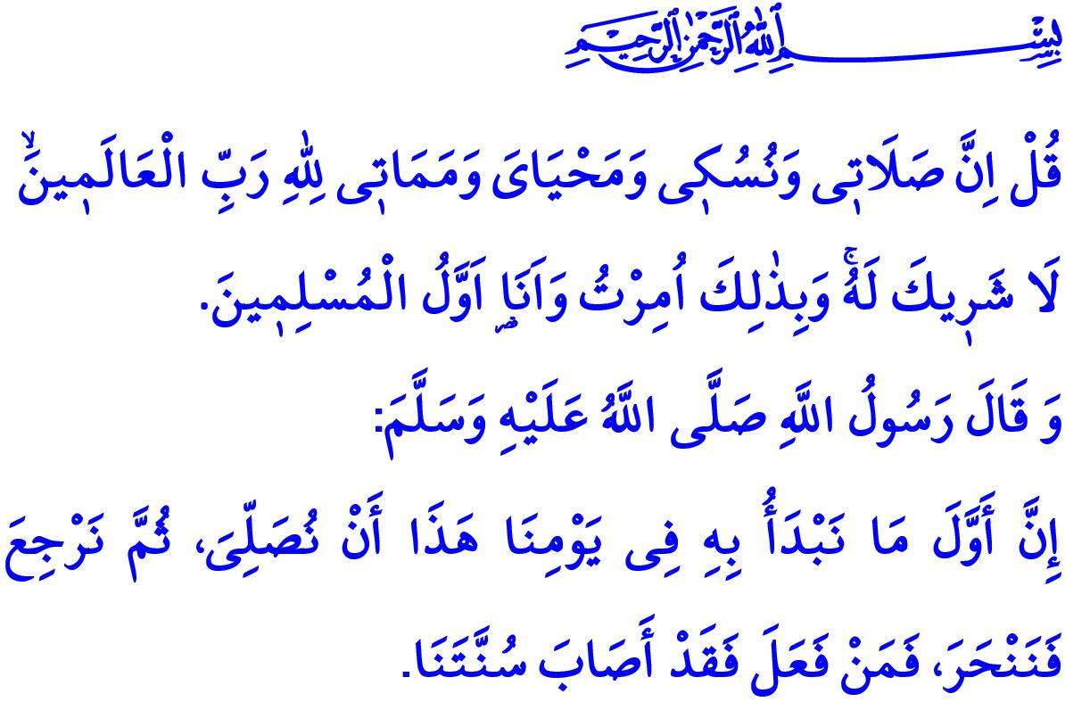
EID AL-ADHA
Honorable Muslims!
Today is the Eid al-Adha. It is an exceptional time when we submit our servitude to Allah (swt) and express our gratitude to Him for all the blessings He bestowed upon us. It is an offering by Him for those people who bear the Prophet Ibrahim's faith, Hajar's loyalty, and the Prophet Ismail's submission. It is the day when the prospective pilgrims enjoy the peacefulness and joy of becoming pilgrims by going to Muzdalifah from Arafat, and to Mina thereafter, stoning the devil, and performing the tawaf al-ziyarah. Today is one of those rare times when we get closer to Allah (swt) by performing the worship of qurban, a distinctive sign of Islam.
Dear Believers!
It was an eid morning just like now, when the Prophet Muhammad (saw) left home to perform the eid prayer. Arriving the place to perform the prayer, he appealed to his companions, “The first thing to do today is to perform the eid prayer, and then perform the worship of qurban. Those who follow this are in conformity with my sunnah.”
In the khutbah he delivered to his companions after performing the eid prayer, he gave the following good news to his ummah, “A human does no action from the actions on the day of nahr more beloved to Allah then spilling blood. On the Day of Judgement, it will appear with its horns, and hair, and hooves, and indeed the blood will be accepted by Allah from where it is received before it even falls upon earth, so let your heart delight in it.”
It was the time to sacrifice the animal after the prayer and the khutbah. The Prophet Muhammad (saw) warned the believers about treating nicely the animals to be sacrificed, and showing mercy and compassion to them as follows, “Allah made it a fardh for people to act based on ikhsan, in other words to act nicely. Then, whoever will sacrifice an animal should do it nicely.” He placed the animal to be sacrificed on the ground facing the qiblah, recited basmalah and takbir, and uttered the following verses:
“I have turned my face toward Allah, Who created the Heavens and the Earth. I am not of the idolaters. Verily, my salah, my sacrifice, my life, and my death are for Allah. He has no partner. And of this I have been commanded, and I am the first of the Muslims.”
Dear Muslims!
Let us spend the days of the Eid al-Adha in conformity to the sunnah of the Prophet Muhammad (saw) as he taught us. Let us bear in mind that we need to utter the tashrik takbir, starting from the morning prayer on the Day of Arafat and ending with the asr prayer on the fourth day of the Eid.
As members of the ummah of the Prophet Muhammad (saw) who says, “Cleanliness makes up half of the faith.” let us pay attention to the environmental cleanliness. We should bury deep in the ground any piece of diseased-looking meat from the sacrificed animal. For, in the event that stray cats and dogs eat such meat, they may transmit diseases to people. We should also ensure that the animals to be sacrificed be slaughtered and apportioned at a clean place.
Dear Believers!
The occasions of eid are the days of sharing, offering, and helping. We should bear in mind that our neighbors, relatives, poor people, orphans, and people in need have their rights over our qurban. Let us remember that we gain as much as we give out, and we get richer as much as we share out.
The silat al-rahim (paying visits to relatives) is the essence of the eid. We should be aware that the days of eid are not only an opportunity for off days. Let us visit the elderly members of our family and show our care in their well-being, particularly our parents. Let us make the younger family members happy with little treats. Let us ensure that the sick, the elderly, and the lone people have their share from the joy of the eid.
Dear Muslims!
The occasions of eid are the days of forgiving and embracing one another. Let us regard the days of the eid as an opportunity to put an end to conflicts and hard feelings between our brothers and sisters. Let us fully enjoy the peacefulness and brotherly climate of the eid.
As I conclude the khutbah, I would like to congratulate our noble nation and the whole Muslim world for the Eid al-Adha. May Allah's (swt) peace, mercy, and blessings be upon you. May this Eid al-Adha bring many beauties for all of us.

Bukhari, 'Eidayn, 3.
Tirmidhi, Adahi, 1.
Muslim, Sayd, 57; Abu Dawud, Dahaya, 10-11.
An'am, 6/79, 162-163; Ibn Majah, Adahi, 1.
Tirmidhi, Daawat, 86. General Directorate of Religious Services

